Organizational Structure/Management of Ayala Land
Management stands as the locus of decision-making for the day-to-day affairs of Ayala. It establishes the company’s strategic direction and infrastructure for success.
Click here to view our Board of Directors.
Ayala Group Management Committee
Ayala is committed to the alignment of its group of companies in core values, vision, and leadership. The members of the Ayala Group Management Committee work together to ensure these goals and maintain the synergies and relationships amongst each company.
Individual profiles may be viewed by clicking on the Management Committee Member's name.
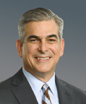  Jaime Augusto  Zobel de Ayala  Chairman and CEO |  | 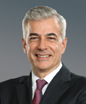  Fernando  Zobel de Ayala  President and COO

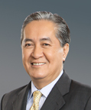  Gerardo C. Ablaza, Jr.  President and CEO  Manila Water Company |  | 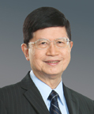  Antonino T. Aquino  President and CEO  Ayala Land, Inc. |  | 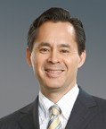  Alfredo I. Ayala  Chief Executive Officer  LiveIt Investments, Ltd. |  | 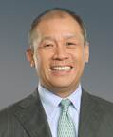  Ernest L. Cu  President and CEO  Globe Telecom
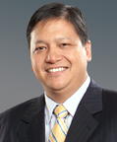  John Eric T. Francia  Group Head,  Corporate Strategy |  | 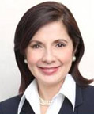  Maria Lourdes Heras-de Leon  President  Ayala Foundation, Inc. |  | 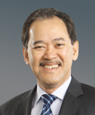  Delfin C. Gonzalez, Jr.  Chief Finance Officer |  | 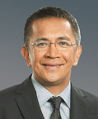  Solomon Hermosura  Group Head,  Legal and Compliance
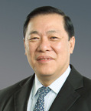  Rufino Luis Manotok  Chairman and CEO  Ayala Automotive Holdings Corporation |  | 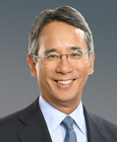  Aurelio Montinola III  President and CEO  Bank of the Philippine Islands |  | 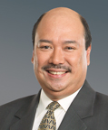  John Philip S. Orbeta  Group Head,  Corporate Resources |  | Arthur R. Tan  President and CEO  Integrated Micro-Electronics, Inc.

AYALA CORPORATION MANAGEMENT COMMITTEE
Parent company Ayala Corporation is committed to adding value to its subsidiaries and providing its shareholders with long-term returns on their investment. The members of the Ayala Corporation Management Committee are dedicated to optimizing the value of Ayala's portfolio of companies.
JAIME AUGUSTO ZOBEL DE AYALA  Chairman and CEO | FERNANDO ZOBEL DE AYALA  President and COO
GERARDO C. ABLAZA, JR.  Senior Managing Director | JOHN ERIC T. FRANCIA  Group Head, Corporate Strategy & Development
DELFIN C. GONZALEZ, JR.  Chief Finance Officer | SOLOMON M. HERMOSURA  Group Head, Legal & Compliance

JOHN PHILIP S. ORBETA
Group Head, Corporate Resources
As disclosed on April 18, 2011

SENIOR MANAGING DIRECTORS
GERARDO C. ABLAZA, JR.  President and CEO  Manila Water Company, Inc. | ANTONINO T. AQUINO  President and CEO  Ayala Land, Inc.
RUFINO LUIS T. MANOTOK  Chairman and CEO  Ayala Automotive Holdings Corporation | ARTHUR R. TAN  President and CEO  Integrated Micro-Electronics, Inc.

MANAGING DIRECTORS
JOHN ERIC T. FRANCIA  Group Head, Corporate Strategy and Development | DELFIN C. GONZALEZ, JR.  Chief Finance Officer
SOLOMON M. HERMOSURA  General Counsel, Corporate Secretary,  and Compliance Officer | RUFINO F. MELO III  Controller
RAMON G. OPULENCIA  Treasurer | JOHN PHILIP S. ORBETA  Group Head, Corporate Resources
GINAFLOR C. ORIS
Head, Corporate Finance and
Asset Management
Seconded to subsidiaries
ALFREDO I. AYALA  Chief Executive Officer  LiveIt Investments, Ltd. | FERDINAND M. DE LA CRUZ  Group Head, East Zone Business Operations  Manila Water Company
MARIA LOURDERS HERAS-DE LEON  President, Ayala Foundation, Inc. | GIL B. GENIO  President  Innove Communications
RONALD LUIS S. GOSECO, JR.  Treasurer and CFO  AC Energy Holdings, Inc. | RICARDO NICANOR N. JACINTO  President and CEO  Habitat for Humanity Philippines
JOSE TEODORO K. LIMCAOCO  President  BPI Family Savings Bank, Inc. | SHERISA P. NUESA  Managing Director  Ayala Land Commercial REIT, Inc.
LUIS JUAN B. ORETA  Chief Finance Officer  Manila Water Company, Inc. | VIRGILIO C. RIVERA, JR.  Head, Regulation and  Corporate Development  Manila Water Company, Inc.
JAIME E. YSMAEL  Chief Finance Officer  Ayala Land, Inc. | RAMON M. ZIALCITA  General Manager  Honda Cars Makati, Inc.
ASSOCIATE DIRECTORS
ALEXANDER T. CORDERO  Internal Auditor | EMILY C. DE LARA  Head, Corporate Communications
FELIPE P. ESTRELLA  Head, Financial Planning and Analysis | ROMUALDO L. KATIGBAK  Assistant Treasurer
NOEL ELI B. KINTANAR  Head, Business Development - Infrastructure | GUILLERMO M. LUZ
MARIA ANGELICA B. RAPADAS  Chief Information Officer | SHEILA MARIE U. TAN  Assistant Corporate Secretary  Legal and Compliance
NORMA P. TORRES  Head, Investor Relations | JAIME P. VILLEGAS  Chief Internal Auditor
Seconded to subsidiaries
RUBY P. CHIONG  CFO, Ayala Malls Group  Ayala Land, Inc. | ROSALLIE A. DIMAANO  Head, Consumer Business Advisory, Finance and Administration Group  Globe Telecom, Inc.
ERWIN P. LOCSIN  LiveIt Investments, Ltd. | MONINA C. MACAVINTA  Group Head, Human Resources  Ayala Automotive Holdings Corporation
RAFAEL NESTOR V. MANTARING  Vice President  Integrated Micro-Electronics, Inc. | JENARA ROSANNA F. ONG  Chief Finance Officer  Ayala Automotive Holdings Corporation
RENE D. PANINGBATAN  General Manager  Isuzu Automotive Dealership, Inc. | ANTONIO J. PINEDA  General Manager  Isuzu Cebu
ALFONSO JAVIER D. REYES  Head, Investor Communications & Compliance  Ayala Land, Inc. | MA. VICTORIA P. SUGAPONG  Chief Risk Officer  Manila Water Company, Inc.
CATHERINE HUFANA-ANG
Group Risk Management
CONSULTANTS/ADVISERS
DELFIN L. LAZARO | MERCEDITA S. NOLLEDO  Senior Counsel
PATRICE RENE CLAUSSE | CARLOS C. REYES  President  Ayala Aviation Corporation
ELIEZER C. TANLAPCO

Board of Directors
The members of the Board of Directors are given the mandate to protect the best interests of shareholders and other stakeholders. At Ayala, we are guided by a long-term view to create and enhance value for our shareholders. As Ayala has been for 175 years, we are motivated by a commitment to being an economic and social development partner of the broader community we serve and of the Filipino nation.
.
Jaime Zobel de Ayala  Chairman Emeritus |  | Jaime Augusto  Zobel de Ayala  Chairman and CEO |  | Fernando  Zobel de Ayala  Vice Chairman
Xavier P. Loinaz  Independent Director |  | Delfin L. Lazaro  Director |  | Nobuya Ichiki  Director |  | Ramon R.  del Rosario, Jr.  Independent Director |  | Antonio Jose U.  Periquet  Independent Director

Board Committees

Executive Committee
Jaime Augusto Zobel de Ayala, Chairman
Fernando Zobel de Ayala
Nobuya Ichiki
Personnel and Compensation Committee
Ramon R. del Rosario, Jr., Chairman
Delfin L. Lazaro
Nobuya Ichiki
Nomination Committee
Ramon del Rosario, Jr., Chairman
Jaime Augusto Zobel de Ayala
Fernando Zobel de Ayala
Audit and Risk Committee
Xavier P. Loinaz, Chairman
Nobuya Ichiki
Ramon R. del Rosario, Jr.
Finance Committee
Delfin L. Lazaro, Chairman
Antonio Jose U. Periquet
Gerardo C. Ablaza, Jr.
Deflin C. Gonzalez, Jr.
John Eric T Francia
Proxy Validation Committee
Solomon M. Hermosura, Chairman
Jaime P. Villegas
Rufino F. Melo III

